Megan Milarcik

Python for Everybody

In the Python for everyone course, I have complete through week four and am now on 8.4 of Data Structures

6.1 – Strings 15m

6.2 - Manipulating Strings 17m

[7.1 - Files](https://www.coursera.org/lecture/python-data/7-1-files-6x7OZ) 8m

7.2 - Processing Files 11m

[8.1 - Lists](https://www.coursera.org/lecture/python-data/8-1-lists-ss3cl) 10m

8.2 - Manipulating Lists 9m

8.3 - Lists and Strings

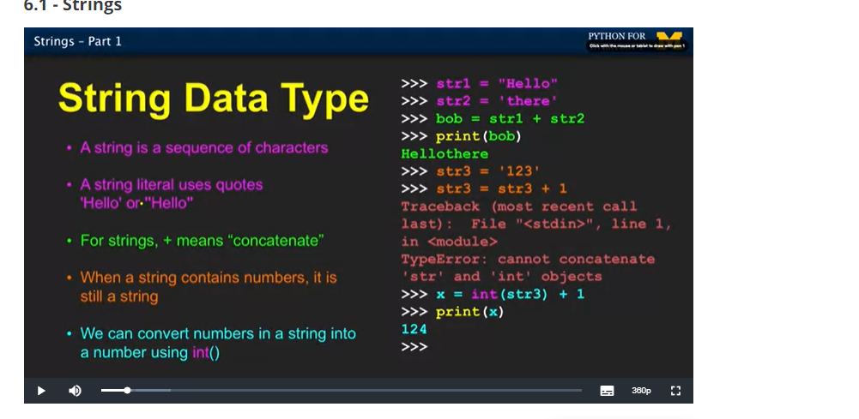

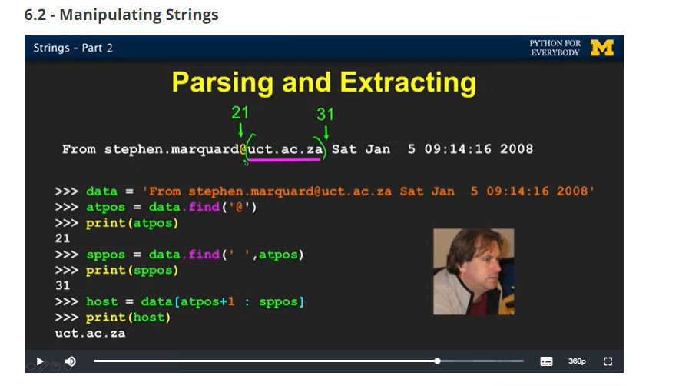

Ch 6 notes

* We read and convert
* Things such as input numbers must be converted to a string
* Colon operator lets us use any section of string
* Concatenation “+” combines strings
* Use in as logical operator
* Python strings stored in string library
* “find” function finds strings within other strings
* Strip whitespace away with lstrip() rstrip()

Ch 7 notes

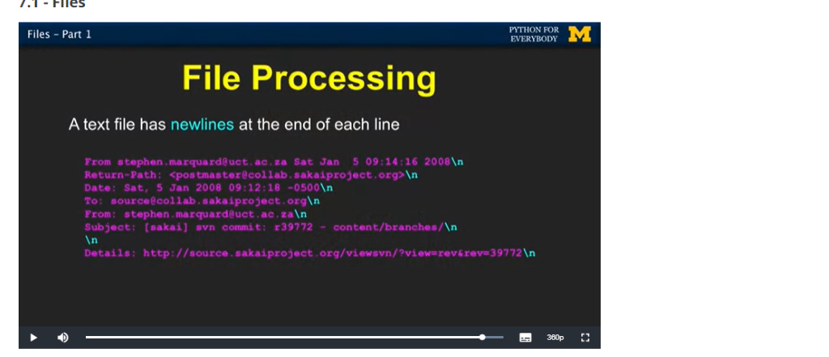

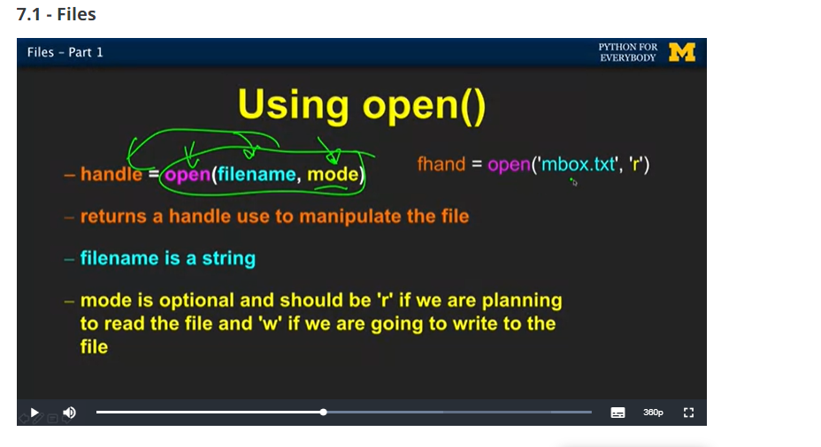

* Input and output devices -à software: . secondary memory

CPU

Main memory

* Open function tells which file
* File handle is a variable used to perform operations
* We use a newline character /n  to indicate when a line ends
* We can use if statement inside a for loop to retrieve lines of code that meet certain criteria
* Continue statement skips a line of code
* What we name files is important
* Chapter 8 notes
* Collection allows us to make many values in a single variable
* List element can be any python object- even another list
* List coincide well with definite loops
* Using index we can change the content of a list, unlike a string which is mutable.
* Range returns list of numbers that’s one less than the parameter
* List can be sliced like strings
* Build a list using append
* 
 